Local government Review
Preferred options of 12 districts, LCC , Blackpool and Blackburn with Darwen
LCC | 2 unitary councils
Blackpool | 4 unitary councils (alternative four)
Blackburn with Darwen | 3 unitary councils
Lancaster | 4 unitary councils
Preston | 4 unitary councils
Ribble Valley | 4 unitary councils
South Ribble | 4 unitary councils
Fylde | 3 unitary councils
Wyre | 3 unitary councils
Chorley | 4 unitary councils
Pendle | 5 unitary councils
Burnley | 5 unitary councils
Rossendale | 3 unitary councils
Hynburn | 3 unitary councils
West Lancs | 4 unitary councils

The proposals
One proposal is to have just two unitary authorities, which has the support of Lancashire County Council.
Under this plan, the county would be split into North and South, broadly divided by the river Ribble.
Lancashire County Council calls it "the most balanced and forward-looking solution."
Three unitary councils
This plan has the support of Wyre, Hyndburn, Blackburn with Darwen, Fylde and Rossendale borough councils.
Under these proposals there would be a coastal authority, covering Blackpool, Fylde, Lancaster and Wyre.
A central authority covering, Chorley, Preston, South Ribble and West Lancashire.
And a Pennine authority, with Blackburn with Darwen, Burnley, Hyndburn, Pendle, Ribble Valley and Rossendale.
Four unitary councils
This has support of Chorley, South Ribble, Ribble Valley, Preston, West Lancashire and Lancaster.
It would see the county made up of North, South, East and West.
North containing Lancaster, Preston and Ribble Valley.
South would be, Chorley, South Ribble, and West Lancashire.
While East would cover Blackburn with Darwen, Burnley, Hyndburn, Pendle and
Rossendale.
West would be Blackpool, Fylde, and Wyre.
So far only South Ribble has formally proposed this, with meetings set to take place at the other authorities shortly.
The leader of South Ribble Council, Matthew Tomlinson, said: "I think the financial modelling done shows that it's just as sustainable as going bigger."
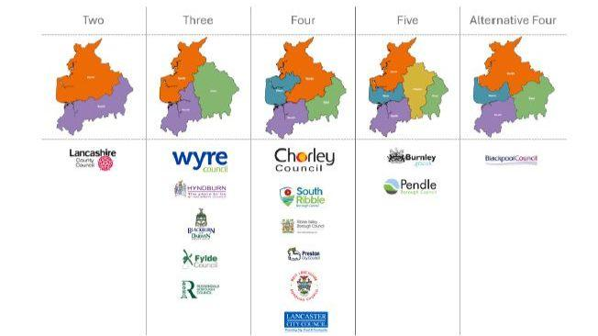Image source,South Ribble Borough Council
Image caption,
There are five different proposals to the council structure
Alternative four
This option has the support of Blackpool council.
It would also like to see four unitary authorities, but would like to see Wyre and Ribble Valley divided up.
So, a council containing Lancaster, Ribble Valley (north), Wyre (east).
Another with Blackburn with Darwen, Hyndburn, Burnley, Pendle, Rossendale, Ribble Valley (south).
A third with South Ribble, Chorley and West Lancashire.
And the fourth being Blackpool, Fylde, Wyre (west), Preston.
Five unitary authorities
This is the favoured option for Burnley and Pendle borough councils, with a petition being launched to try and stop them being merged with Blackburn.
It would see a Northern council made up of Lancaster and Wyre.
An Eastern, made up of Burnley, Pendle and Rossendale, with a Mid-Eastern made up of Blackburn with Darwen, Hyndburn and Ribble Valley.
A Southern, with South Ribble, Chorley and West Lancashire.
And a Western, made up of Blackpool, Fylde and Preston.

